# Department of Computing

# CS110: Fundamental of Computer Programming

# Class: BSCS-5C

# Lab 13: Speed Programming Competition

# Date: 11-01-2017

# Time: 10:00 to 01:00

# Instructor: Dr Anis ur Rehman

# Lab 13: Speed Programming Competition

**Instructions for Competition**

**Duration:**   
Total duration span of the competition is 3 hours.

Time Distribution is as under

1. Level one 50 Minutes
2. Level two 40 Minutes
3. Level three 30 Minutes
4. Level four 25 Minutes

**Levels**

Total No of levels are four.

**Programming Languages:**   
Allowable programming language in which participants can make the programs for the given problems is C.

**General Rules:**

1. Use of mobile phones and other communication devices is strictly prohibited during the competition. Anyone seen using devices will be immediately disqualified. Such devices should be switched off and placed in pockets / hand bags and not visible or accessible during the competition.
2. During the contest you are not allowed to collaborate or discuss problem with anyone but you can take online help.

**Rules for Program Submission:**

1. The competition would include a number of challenging problems each of which would require you to develop some programs and get the output in a fixed format on the console.
2. You will be required to submit the program files (Problem1.c etc) only. Each file should be named as according to the problem number. All files should be placed in a folder named after the participant Name. Programs should be properly commented.

**Scoring Rules:**

1. You are ranked according to the number of problems solved; a participant solving more problems is always ranked higher than a participant solving fewer problems.
2. If two or more participant have the same number of solved problems, ties are broken in favour of the student with the earliest time of the final submission.
3. The decision of the Judges will be final

**Level 1**

**Total Time 50 Minutes**

**Note: You can use any of the loops (for, while or do-while loop), unless specified in the question.**

1. In a company, worker efficiency is determined on the basis of the time required for a worker to complete a particular job. If the time taken by the worker is between 2 – 3 hours, then the worker is said to be highly efficient. If the time required by the worker is between 3 – 4 hours, then the worker is ordered to improve speed. If the time taken is between 4 – 5 hours, the worker is given training to improve his speed, and if the time taken by the worker is more than 5 hours, then the worker has to leave the company. If the time taken by the worker is input through the keyboard, find the efficiency of the worker.
2. Write a program to enter 15 numbers from the keyboard and at the end it should display the count of positive, negative and zeros entered using **while loop.** Output should look like:

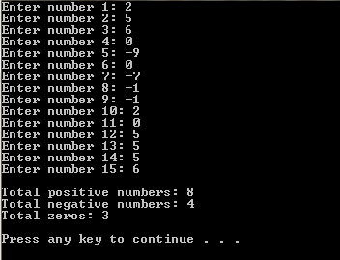

1. Write a program that asks the user for five numbers and then finds and displays the maximum and minimum number.
2. Write a program to calculate and display the sum and average of 1 to n in steps of s, where n and s are integer-type inputs from the keyboard such that s denotes the step size between 1 and n. For example, if n=21 and s=3 are passed, it will display the result of sum and average of 1 + 4 + 7 + 10 + 13 + 16 + 19.